ATHENA - AUTONOMOUS TRIAGE AND HEALTHCARE ELECTRONIC NEURAL ASSISTANT
Conclusion, Future Scope and References
Department of Computer Science and Engineering, TKR College of Engineering & Technology
Batch A7 (CSE-A) · Academic year [ACADEMIC YEAR]
Table 1: Project team
S.No. | Student name | Roll number
1 | Badaveni Srinath | 23K91A0523
2 | Basani Avinash | 23K91A0532
3 | Degala Praneeth | 23K91A0561
4 | Bontha Saisree | 23K91A0545

Project guide: K. Shalini
Chapter and section numbers quoted in the text (for example Chapter 8 or Section 6.2) refer to the full project report, 17.Final Document. Figures and tables in this document are numbered from 1.

1. CONCLUSION

1.1 Summary of the work
This project built ATHENA, a decision-support tool for emergency departments. It reads a scanned clinical report (PDF text layer or local OCR), parses symptoms, findings, history and six laboratory values with a lexicon that handles negation, fuses them with eight vitals into 36 inputs, and uses an isotonic-calibrated XGBoost to give a triage priority from 1 to 5, a risk level and a calibrated confidence. Per-patient SHAP shows the strongest drivers, a clinician accepts or changes the priority with a reason, and the queue, the performance page and a summary PDF follow from that. The system was measured on a seeded synthetic data set (6,000 cases, 1,200 held out), compared with seven other models, probed for calibration, robustness and safety, and verified with 47 automated tests and 17 smoke checks.

1.2 Objectives achieved
Table 2: The six objectives of the batch against the outcome
# | Objective | Outcome
1 | OCR stage for scanned reports | Met: PDF text layer plus local RapidOCR (PaddleOCR-family models on ONNX Runtime); 12 of 12 generated samples read exactly; real scans untested
2 | Medical language model to extract symptoms, findings, history | Partly met: a lexicon with negation, not BioBERT; precision 95.2% and recall 84.3% on 40 hand-written fragments
3 | Fuse text features with vitals in one representation | Met: 36 inputs; fused 68.25% against 40.58% (vitals) and 63.17% (report)
4 | Model assigns risk level and priority | Met on synthetic labels: 69.4% exact, 99.7% within one level, macro F1 0.670
5 | Explanation layer showing what drove the priority | Met: per-patient SHAP, strongest factor first, with the page each finding came from
6 | Accuracy against clinician-assigned priority; time per patient | Partly met: accuracy against the synthetic recorded priority only; median 30 ms for a PDF and 2.1 s for a scan, end to end over HTTP

1.3 Key findings
1. Fusing the report with the vitals pays on this data. Exact accuracy is 68.25% fused, 63.17% report only and 40.58% vitals only; within one level the fused model is right 99.7% of the time.
2. The shipped model recovers its rule well but not perfectly. 69.4% exact, 99.7% within one level, macro F1 0.670, quadratic weighted kappa 0.880, Top-2 95.3%; the label noise caps any model near 86.25%.
3. The sickest patients are the weak point. Priority 1 recall is 43.9% and high-risk (P1 and P2) recall 66.2%. Flagging high risk when P(1) + P(2) is at least 0.4 would raise recall to 84.3% at precision 81.6%; this threshold is not implemented.
4. A simple baseline matches the chosen model. Logistic regression 72.42%, MLP 70.92%, XGBoost 68.25% (uncalibrated); five-fold XGBoost accuracy is 72.4% (sd 1.5).
5. Confidence is informative but coarse. Calibration lowers ECE only from 0.047 to 0.041; keeping predictions with confidence of at least 0.85 covers 25.5% of cases at 87.6% accuracy, and 0.9 covers 20.2% at 94.2%.
6. The reader is the fragile stage. 100% on generated samples, recall 84.3% on hand-written fragments, and the triage model loses accuracy quickly when findings are dropped (66.2% at 10%, 62.1% at 20%, 33.9% with no report).
7. Against the base paper ATHENA shares the ideas of ranked output, a 0.85 confidence threshold, SHAP and absent-equals-zero, but the task (five priorities against 87 ICD-10 classes) and the data (synthetic against 1,655 real cases) differ, so no accuracy comparison is claimed.

1.4 Practical applications
• A teaching and prototyping platform for decision support that reads documents, fuses them with measurements, explains itself and records the clinician's decision.
• A reference design for triage software: queue ordered by priority then arrival, reasons beside each decision, override log, summary PDF.
• A starting point for training on real triage records once such a data set is available (Chapter 10), with the evaluation scripts already in place.
• A template for reporting a clinical-AI result honestly: data source in every sentence, baselines, ceiling, calibration, safety direction and robustness.

1.5 Known limitations
All model results are on synthetic data; priority-1 recall is 43.9% and under-triage 21.3%; a linear model is as good as the shipped one; the reader is a lexicon with known negation and OCR defects; BioBERT, RAG, multi-agent orchestration, LIME, MongoDB and the six disease-risk models were not built; security is demo-grade; and no clinician used the system. Chapter 8 and the Scope and Limitations document give the full list.

1.6 Lessons learned
• Write the data a number was measured on in the same sentence as the number; a synthetic 69% and a real-hospital 69% are different claims.
• Run the simple baseline first. Logistic regression beating XGBoost would have stayed hidden without a comparison table.
• Work out the noise ceiling of a synthetic data set before celebrating or lamenting an accuracy.
• Test the reader on text it was not written for; the generated samples gave 100% and the first honest stress test gave 84.3% recall.
• Keep experiments scripted and their output stored as JSON, so every number in the documents can be traced and regenerated.
The results behind the key findings are shown below: how the shipped model compares with seven other classifiers on the same synthetic split, and how the base paper's setting sits next to ATHENA's.
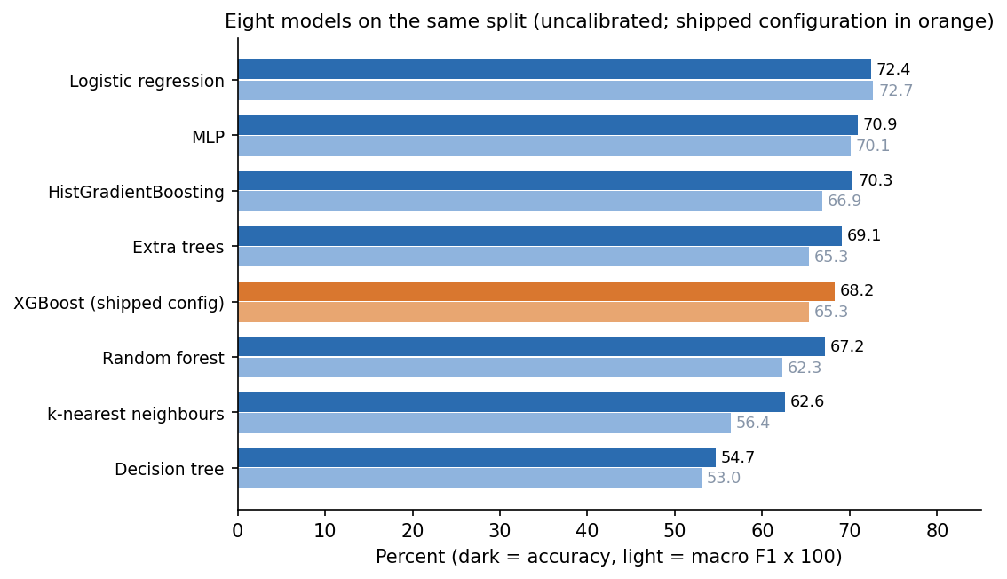
Figure 1: Exact accuracy and macro F1 of eight classifiers on the same 1,200 synthetic hold-out cases.
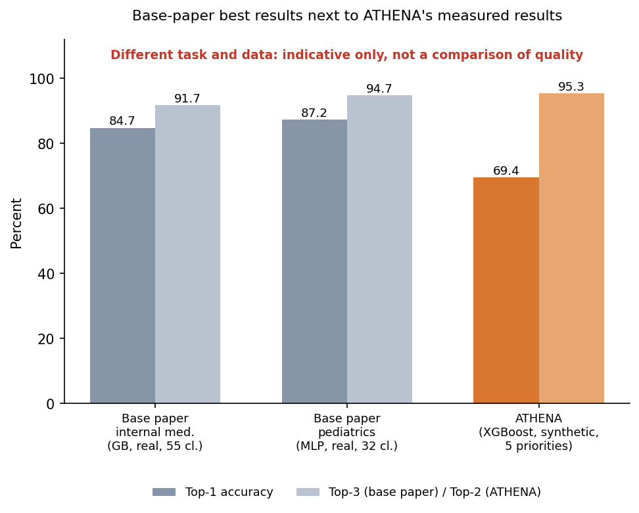
Figure 2: The base paper's setting and results beside ATHENA's (different task, classes and data: indicative context only, not a like-for-like comparison).

2. FUTURE SCOPE

2.1 Improvements to the existing system
• Train and test on real triage records. The Kaggle "Hospital Triage and Patient History Data" set is wired to scripts/download_data.py (never run; licence not stated); MIMIC-IV-ED is a public benchmark but needs credentialed access [13]. Report agreement with recorded triage levels, per-level recall and calibration on a patient-disjoint split.
• Add the high-risk safeguard. Raise a High-risk flag when P(1) + P(2) is at least 0.4: on the synthetic hold-out this raises P1-P2 recall from 66.2% to 84.3% at precision 81.6% (against 90.6%); choose the threshold on validation data with clinicians.
• Improve negation scope and OCR tolerance. Stop the window at "but" and "however", handle post-positioned negation ("absent") and prefixes ("afebrile"), join split OCR words, and fix the emesis match inside haematemesis.
• Better calibration. Compare temperature scaling and merged bins with isotonic regression; the 0.8 to 0.9 confidence bin is over-confident today (ECE 0.041).
• Replace the lexicon by a clinical language model (BioBERT-class [22]) for extraction, keeping the lexicon as a fallback and the stress set as the regression test.
• Strengthen security. Require JWT_SECRET, add HTTPS, rate limiting, audit logging of views and downloads, and remove the seeded passwords.

2.2 Additional features
• Chief-complaint and pain-score inputs, which real triage relies on, and free-text notes next to the scan.
• Retrieval of guidance (RAG) so that a priority comes with the relevant protocol passage, and multi-agent checks (for example a second reader that audits the first) as named in the batch abstract.
• LIME or counterfactual explanations next to SHAP, and an explanation of why a finding was not read.
• Disease-risk modules for diabetes, heart disease, chronic kidney disease, breast cancer, liver disease and sepsis, as named in the batch brief, each with its own evaluation.
• Trend views for repeated vitals and an alert when a waiting patient's risk changes.

2.3 Scalability and deployment
• Move from SQLite to a server database, run several API workers behind a reverse proxy, and cache the OCR engine per worker; creating a patient already takes a median 22 ms, so reading scanned images (about 2.2 s each on this CPU) is the cost that needs a worker pool or a GPU.
• Integrate with hospital systems through HL7 or FHIR and a monitor feed instead of typed vitals.
• Containerise the service, publish the model bundle with its metrics and monitor the distribution of inputs and of clinician overrides in production, retraining when they drift.

2.4 Further research
• A prospective, clinician-in-the-loop study: how often is the suggestion kept, and does the explanation change the clinician's decision?
• Fairness checks across age and arrival mode on real data, and measurement of under-triage by subgroup.
• Comparison of tree models, linear models and small networks on real triage records, following the tabular-data evidence [21].
• Top-k and abstention policies: when the model should refuse to suggest a priority, building on the confidence-coverage curve measured here.
• Reporting to a clinical-AI standard such as TRIPOD+AI [30] once real data are used.

2.5 Suggested order of work
Table 3: Future work ranked by value and effort
Priority | Item | Effort | Why first
1 | Real triage data set and patient-disjoint evaluation | Medium | Turns every figure from a statement about a rule into one about patients
2 | High-risk threshold and clinician review of it | Small | Recall of P1-P2 66.2% to 84.3% on the synthetic hold-out
3 | Negation, abbreviation and OCR fixes with a larger independent stress set | Small to medium | Reader recall is 84.3% on hand-written fragments
4 | Security hardening and audit log | Small to medium | Closes the demo shortcuts that block any real use
5 | Clinical language model for extraction | Large | Addresses paraphrases the lexicon cannot read
6 | User study and prospective evaluation | Large | The only way to show the tool helps a clinician

3. REFERENCES
[1] M. Mlodawski, S. Deniziak, M. Plaza, A. Kwiatkowska, D. Jaszczyk, A. Gajda and K. Twardowski, "Multidimensional analysis of the diagnostic performance of machine learning models in disease classification: implications for clinical decision support systems," IEEE Access, vol. 14, pp. 92149-92177, 2026, doi: 10.1109/ACCESS.2026.3703248.
[2] "Identifying the high-risk obstetric patient at triage," J. Emerg. Nurs., 2026 (authors, volume and pages not verified).
[3] "The effects of patient triage management strategies on clinical outcomes and risk management in emergency departments: a prospective comparative study," Anatolian Curr. Med. J., vol. 7, no. 1, Jan. 2025.
[4] T. L. Pinn-Woodcock, J. Pigott and S. A. L. DeNotta, "Emergency diagnostic assessment during triage," in Emergency Triage of the Horse. Hoboken, NJ, USA: Wiley, 2025, ch. 6, p. 91.
[5] "Assessment of knowledge of triage among patient attendants presenting in the emergency department: a single center observational study," J. Gen. Pract. Emerg. Med. Nepal, 2024 (authors and pages not verified).
[6] H. Cheng, C. Yu, Y. Shi, C. Wang, C. Liu and Z. Jin, "Collaborative medical triage under uncertainty: a multi-agent dynamic matching approach," arXiv:2507.22504, Jul. 2025.
[7] H. Jang, G. Chu, C. Kim, J. Park et al., "TRIAGE: dialectical reasoning for explainable risk prediction on irregularly sampled medical time series with LLMs," arXiv:2606.09030, Jun. 2026.
[8] M. Fernandes, S. M. Vieira, F. Leite, C. Palos, S. Finkelstein and J. M. C. Sousa, "Clinical decision support systems for triage in the emergency department using intelligent systems: a review," Artif. Intell. Med., vol. 102, Art. no. 101762, Jan. 2020, doi: 10.1016/j.artmed.2019.101762.
[9] J. S. Hinson, D. A. Martinez, S. Cabral et al., "Triage performance in emergency medicine: a systematic review," Ann. Emerg. Med., vol. 74, no. 1, pp. 140-152, Jul. 2019, doi: 10.1016/j.annemergmed.2018.09.022.
[10] W. S. Hong, A. D. Haimovich and R. A. Taylor, "Predicting hospital admission at emergency department triage using machine learning," PLoS ONE, vol. 13, no. 7, Art. no. e0201016, Jul. 2018, doi: 10.1371/journal.pone.0201016.
[11] S. Levin et al., "Machine-learning-based electronic triage more accurately differentiates patients with respect to clinical outcomes compared with the Emergency Severity Index," Ann. Emerg. Med., vol. 71, no. 5, pp. 565-574, May 2018, doi: 10.1016/j.annemergmed.2017.08.005.
[12] Y. Raita et al., "Emergency department triage prediction of clinical outcomes using machine learning models," Crit. Care, vol. 23, Art. no. 64, Feb. 2019, doi: 10.1186/s13054-019-2351-7.
[13] F. Xie et al., "Benchmarking emergency department prediction models with machine learning and public electronic health records," Sci. Data, vol. 9, Art. no. 658, Oct. 2022, doi: 10.1038/s41597-022-01782-9.
[14] N. Gilboy, P. Tanabe, D. Travers and A. M. Rosenau, Emergency Severity Index (ESI): A Triage Tool for Emergency Department Care, Version 4, Implementation Handbook 2012 Edition, AHRQ Pub. no. 12-0014. Rockville, MD, USA: Agency for Healthcare Research and Quality, 2011.
[15] T. Chen and C. Guestrin, "XGBoost: a scalable tree boosting system," in Proc. 22nd ACM SIGKDD Int. Conf. Knowl. Discovery Data Mining, San Francisco, CA, USA, 2016, pp. 785-794, doi: 10.1145/2939672.2939785.
[16] S. M. Lundberg and S.-I. Lee, "A unified approach to interpreting model predictions," in Proc. Adv. Neural Inf. Process. Syst. (NeurIPS), vol. 30, 2017, pp. 4765-4774, arXiv:1705.07874.
[17] S. M. Lundberg et al., "From local explanations to global understanding with explainable AI for trees," Nat. Mach. Intell., vol. 2, no. 1, pp. 56-67, Jan. 2020, doi: 10.1038/s42256-019-0138-9.
[18] B. Zadrozny and C. Elkan, "Transforming classifier scores into accurate multiclass probability estimates," in Proc. 8th ACM SIGKDD Int. Conf. Knowl. Discovery Data Mining, Edmonton, AB, Canada, 2002, pp. 694-699, doi: 10.1145/775047.775151.
[19] A. Niculescu-Mizil and R. Caruana, "Predicting good probabilities with supervised learning," in Proc. 22nd Int. Conf. Mach. Learn. (ICML), Bonn, Germany, 2005, pp. 625-632, doi: 10.1145/1102351.1102430.
[20] C. Guo, G. Pleiss, Y. Sun and K. Q. Weinberger, "On calibration of modern neural networks," in Proc. 34th Int. Conf. Mach. Learn. (ICML), PMLR vol. 70, 2017, pp. 1321-1330.
[21] L. Grinsztajn, E. Oyallon and G. Varoquaux, "Why do tree-based models still outperform deep learning on typical tabular data?" in Proc. Adv. Neural Inf. Process. Syst. (NeurIPS) Datasets Benchmarks Track, vol. 35, 2022, pp. 507-520, arXiv:2207.08815.
[22] J. Lee, W. Yoon, S. Kim, D. Kim, S. Kim, C. H. So and J. Kang, "BioBERT: a pre-trained biomedical language representation model for biomedical text mining," Bioinformatics, vol. 36, no. 4, pp. 1234-1240, Feb. 2020, doi: 10.1093/bioinformatics/btz682.
[23] Y. Du et al., "PP-OCR: a practical ultra lightweight OCR system," arXiv:2009.09941, Sep. 2020.
[24] L. Breiman, "Random forests," Mach. Learn., vol. 45, no. 1, pp. 5-32, Oct. 2001, doi: 10.1023/A:1010933404324.
[25] F. Pedregosa et al., "Scikit-learn: machine learning in Python," J. Mach. Learn. Res., vol. 12, pp. 2825-2830, 2011.
[26] M. T. Ribeiro, S. Singh and C. Guestrin, "'Why should I trust you?': explaining the predictions of any classifier," in Proc. 22nd ACM SIGKDD Int. Conf. Knowl. Discovery Data Mining, San Francisco, CA, USA, 2016, pp. 1135-1144, doi: 10.1145/2939672.2939778.
[27] M. Plaza, "Multimodal system for automated medical documentation and clinical decision support integrating contact center solutions," Sci. Rep., vol. 16, no. 1, p. 15017, Mar. 2026, doi: 10.1038/s41598-026-45879-2.
[28] P.-F. Chen et al., "Automatic international classification of diseases coding system: deep contextualized language model with rule-based approaches," JMIR Med. Informat., vol. 10, no. 6, Art. no. e37557, Jun. 2022, doi: 10.2196/37557.
[29] H. Takita et al., "A systematic review and meta-analysis of diagnostic performance comparison between generative AI and physicians," npj Digit. Med., vol. 8, no. 1, p. 175, Mar. 2025, doi: 10.1038/s41746-025-01543-z.
[30] G. S. Collins et al., "TRIPOD+AI statement: updated guidance for reporting clinical prediction models that use regression or machine learning methods," BMJ, vol. 385, Art. no. e078378, Apr. 2024, doi: 10.1136/bmj-2023-078378.
[31] J. G. Richens, C. M. Lee and S. Johri, "Improving the accuracy of medical diagnosis with causal machine learning," Nat. Commun., vol. 11, no. 1, p. 3923, Aug. 2020, doi: 10.1038/s41467-020-17419-7.
[32] B. Vasey et al., "Association of clinician diagnostic performance with machine learning-based decision support systems: a systematic review," JAMA Netw. Open, vol. 4, no. 3, Art. no. e211276, Mar. 2021, doi: 10.1001/jamanetworkopen.2021.1276.

